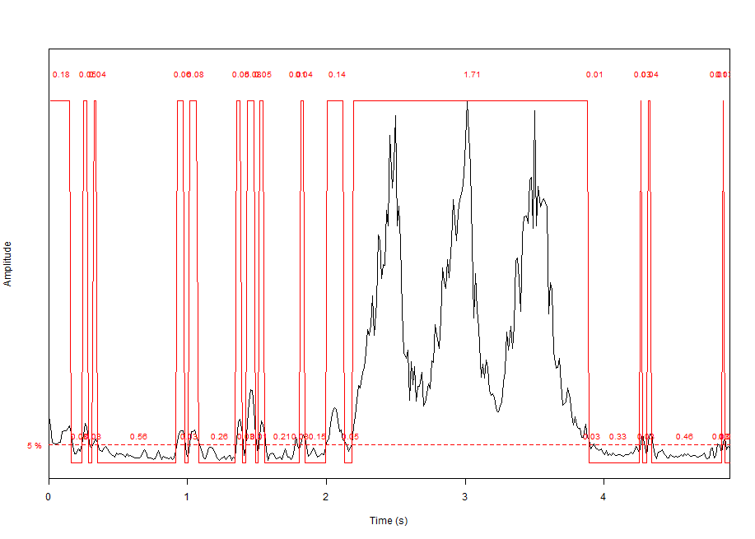a)

This sound at the beginning has noise as there’s small wave starting from 0 – 2 sec as well as the low amplitude producing low volume. After 2 sec there’s increase in frequency the pitch started to produce and increases the pitchness as the frequency increases. So does the amplitude also increases from 0.0 – 2.0^11 resulting in high volume of sound until nearly 4sec the frequency decreases, amplitude decreases and noise starting to return. The volume decreases and become slow and the pitchness has also decreases.

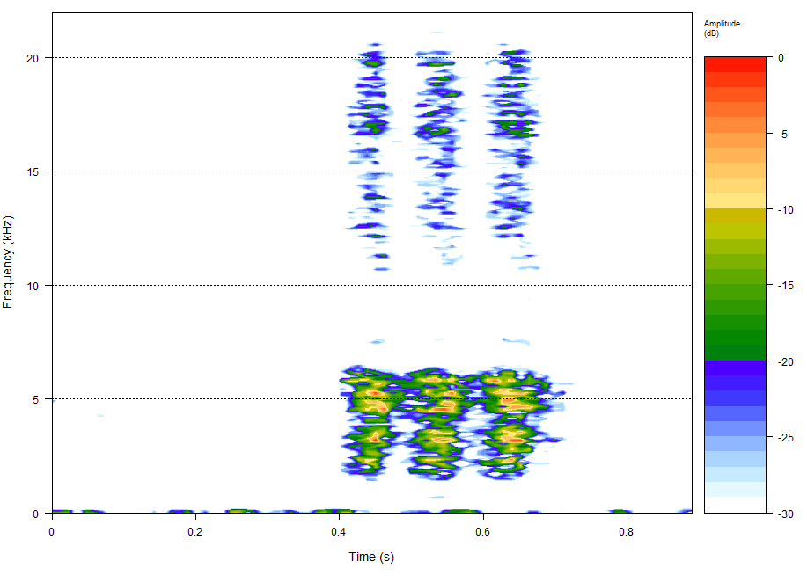b)

Based on the spectrogram on this audio, we notice that the major color is blue compared to other colors like yellow, red, green. The color range indicates the amplitude which define the loudness or volume of the sound. The bluer the color, the higher the volume. And the volume of the sound for this audio is increases with color from green, yellow and a hint of red meaning there’s slightly high volume there but not long enough to compare to when the sound has low volume. From time 0.4 – 0.7 sec the frequency is about ~2 – 6kHz meaning that at this time the pitch of the sound is low as well as the volume of the audio but sometimes the volume increases (due to color combination green, yellow, red). And above 10kHz the volume increases and the frequency increases mean it have high pitch and high volume.

c)

left channel

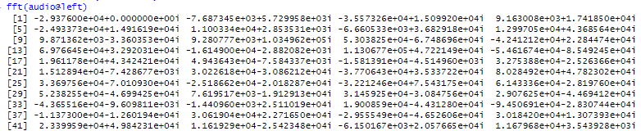

spectrum plotting

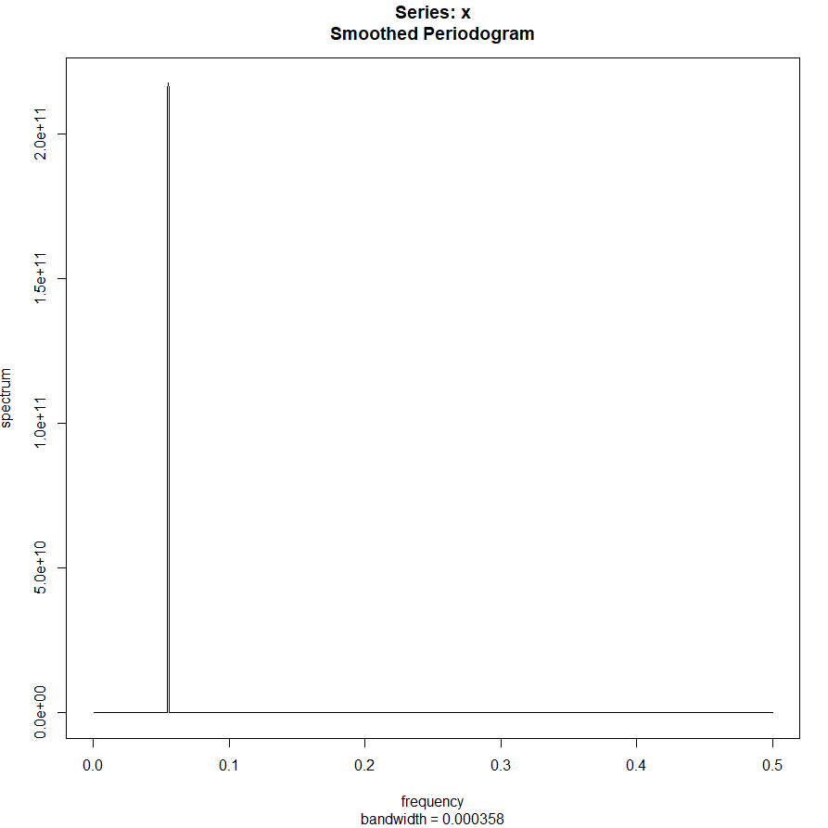

Frequency spectrum plotting

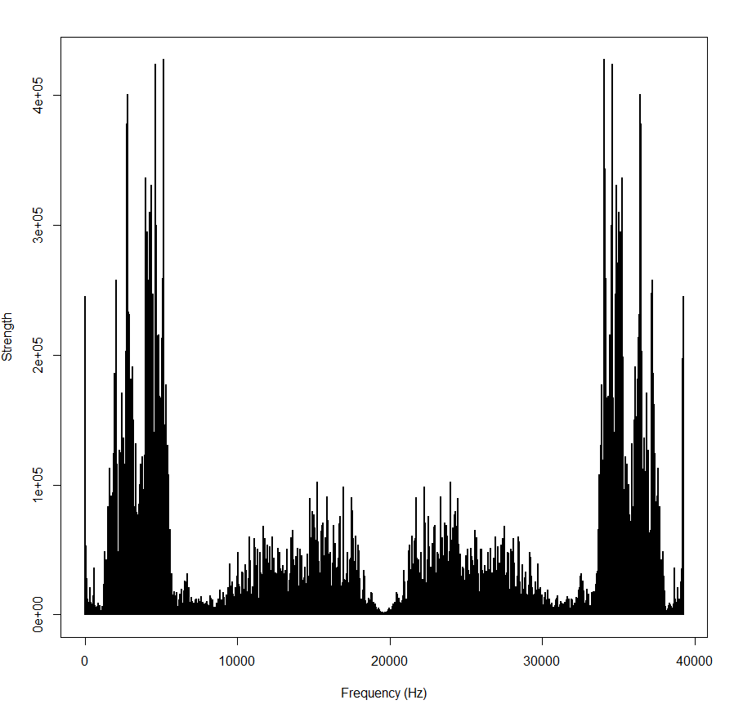

The strength of the frequency defines the high of the pitchness of the sound. High pitch at 0 – 1000. Low pitch from 10000-3000